## Initial simple test:

Main table:

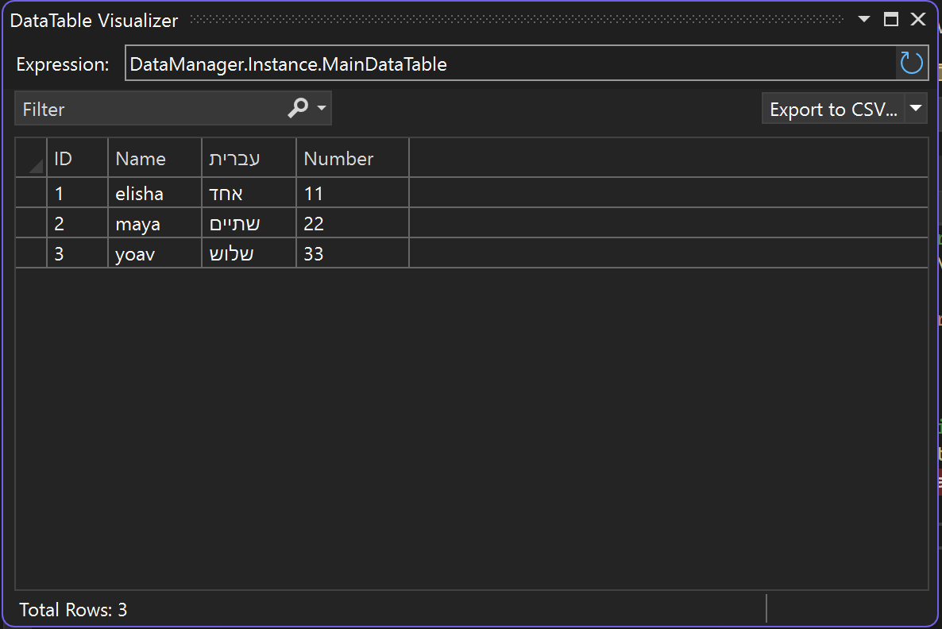

Combined result:

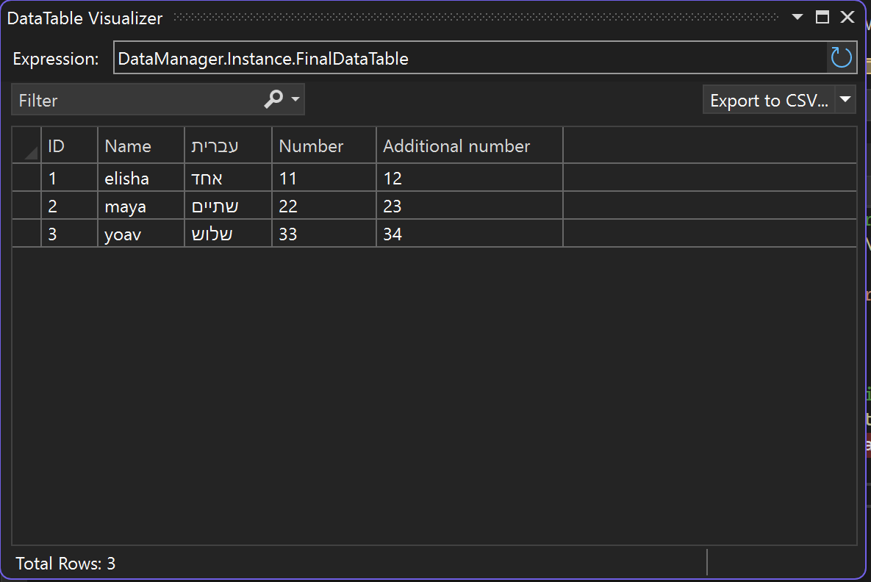

Result: Success!

## Reordering test

Worked!

## Missing values test

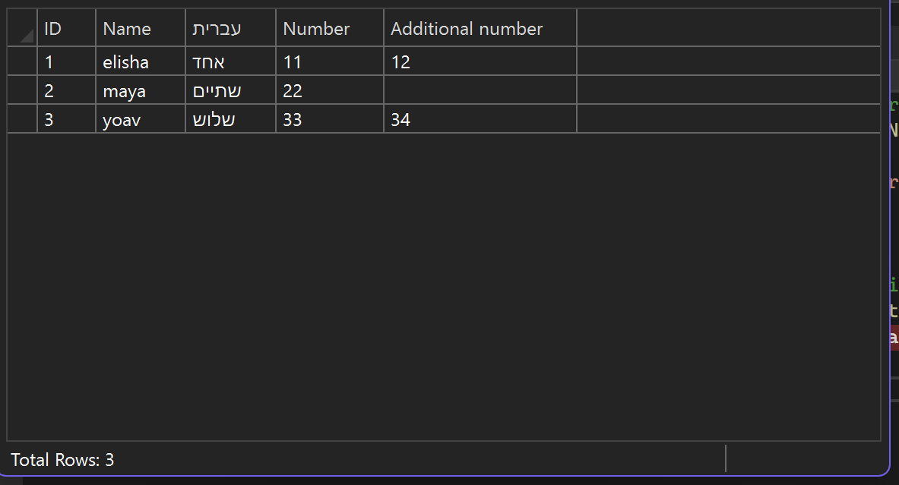

Worked!

## Additional values test

Main:

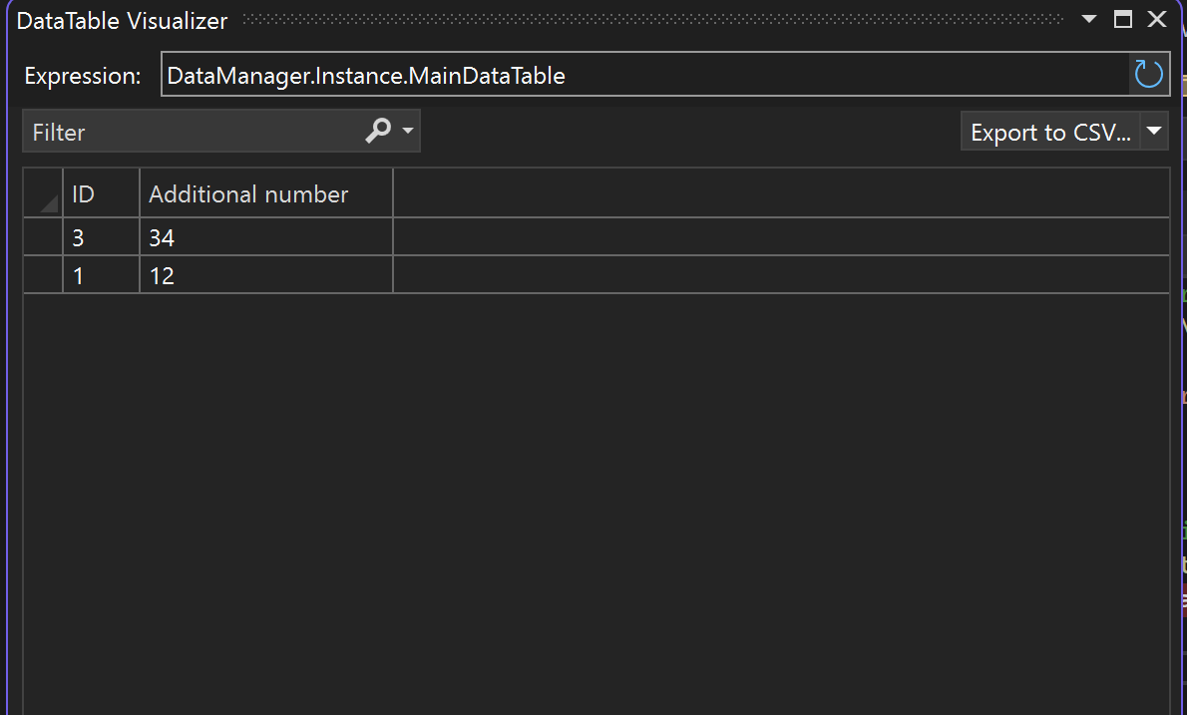

Final:

Worked! (Only works by the values of the main table – worth noting that additional values from the enriching table won’t affect anything)

## Workload test?

Main file:

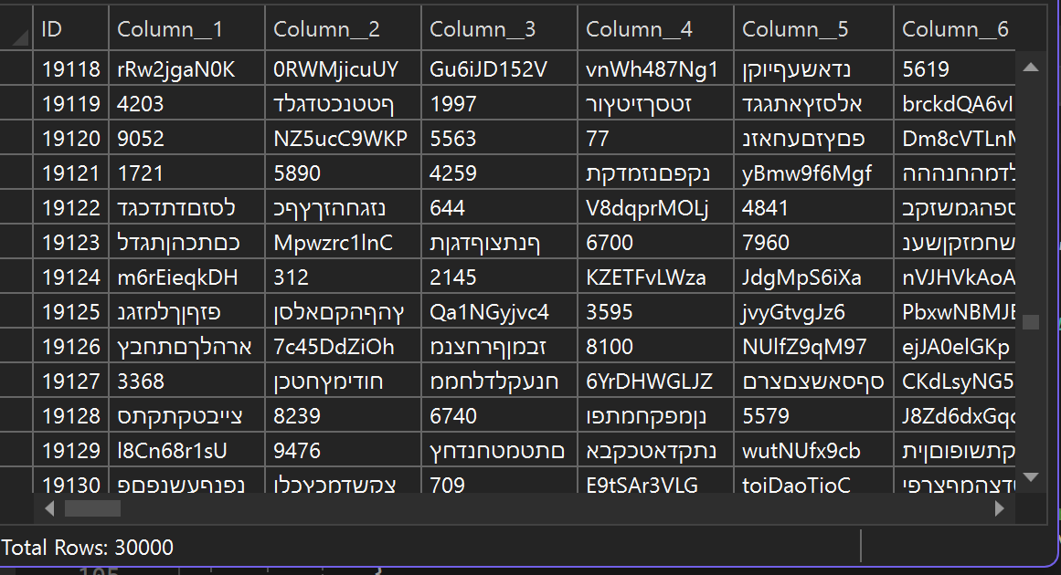

Combined:

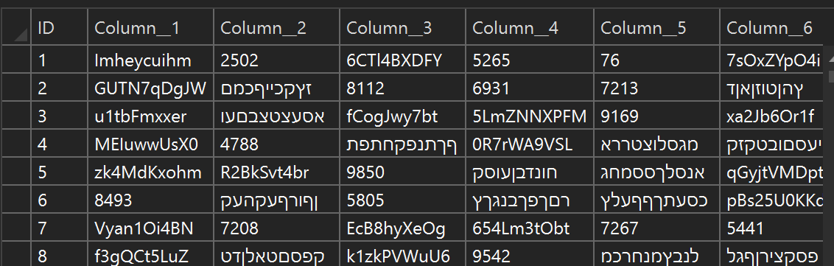

The loading and combining worked decently quickly… But do same column names override one another?

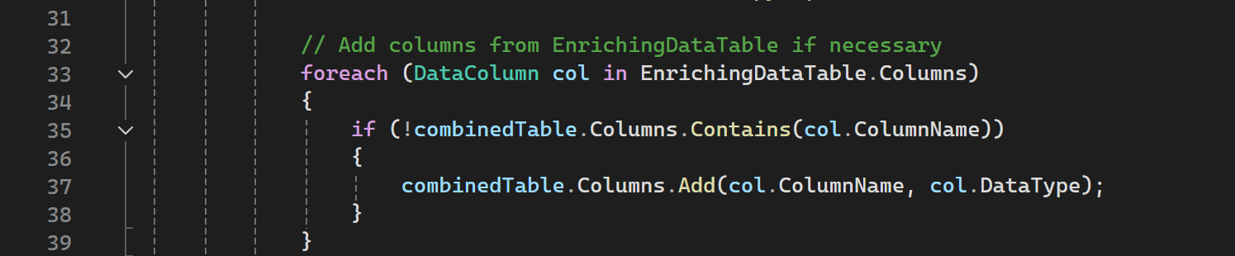

Indeed…

For now – not necessarily worth changing… but worth keeping in mind…